Experiment 5

Name: Veeransh Shah

Reg No: 221070063

Theory:

Creating a simple GUI application using Tkinter in Python is relatively straightforward. Tkinter is a standard Python library for creating GUI applications. Here's a simple example to help you get started:

Code:

# Import Module

from tkinter import *

root = Tk()

root.title("Calculator")

root.geometry("300x350")

text=Entry(root,font=("calibri",16))

text.pack(fill=X,padx=15,ipadx=15,ipady=15)

def addToText(n):

    text.insert(END,n)

def calculate():

   result = eval(text.get())

   text.delete(0,END)

   text.insert(0,result)

def clear():

     text.delete(0,END)

# Text Bar

frame=Frame(root)

frame.pack(side=TOP,anchor=NW)

# CLEAR ICON

rightFrame=Frame(frame)

rightFrame.pack(side=RIGHT)

frame1=Frame(frame)

frame1.pack()

# Number Row 1

btn1 = Button(frame1,text="1",width=9,height=3,command=lambda:addToText("1"))

btn1.pack(side=LEFT)

btn2 = Button(frame1,text="2",width=9,height=3,command=lambda:addToText("2"))

btn2.pack(side=LEFT)

btn3 = Button(frame1,text="3",width=9,height=3,command=lambda:addToText("3"))

btn3.pack(side=LEFT)

frame2=Frame(frame)

frame2.pack()

# Number Row 2

btn4= Button(frame2,text="4",width=9,height=3,command=lambda:addToText("4"))

btn4.pack(side=LEFT)

btn5 = Button(frame2,text="5",width=9,height=3,command=lambda:addToText("5"))

btn5.pack(side=LEFT)

btn6 = Button(frame2,text="6",width=9,height=3,command=lambda:addToText("6"))

btn6.pack(side=LEFT)

frame3=Frame(frame)

frame3.pack()

# Number Row 3

btn7= Button(frame3,text="7",width=9,height=3,command=lambda:addToText("7"))

btn7.pack(side=LEFT)

btn8= Button(frame3,text="8",width=9,height=3,command=lambda:addToText("8"))

btn8.pack(side=LEFT)

btn9 = Button(frame3,text="9",width=9,height=3,command=lambda:addToText("9"))

btn9.pack(side=LEFT)

frame4=Frame(frame)

frame4.pack()

btnpt= Button(frame4,text=".",width=9,height=3,command=lambda:addToText("."))

btnpt.pack(side=LEFT)

btn0= Button(frame4,text="0",width=9,height=3,command=lambda:addToText("0"))

btn0.pack(side=LEFT)

btneq = Button(frame4,text="=",width=9,height=3,command=lambda:calculate())

btneq.pack(side=LEFT)

btndiv = Button(rightFrame,text="/",width=9,height=3,command=lambda:addToText("/"))

btndiv.pack()

btnmul = Button(rightFrame,text="x",width=9,height=3,command=lambda:addToText("*"))

btnmul.pack()

btnsub= Button(rightFrame,text="-",width=9,height=3,command=lambda:addToText("-"))

btnsub.pack()

btnadd = Button(rightFrame,text="+",width=9,height=3,command=lambda:addToText("+"))

btnadd.pack()

btn123 = Button(rightFrame,text="Clear",width=9,height=3,command=lambda:clear())

btn123.pack()

root.mainloop()

Output:

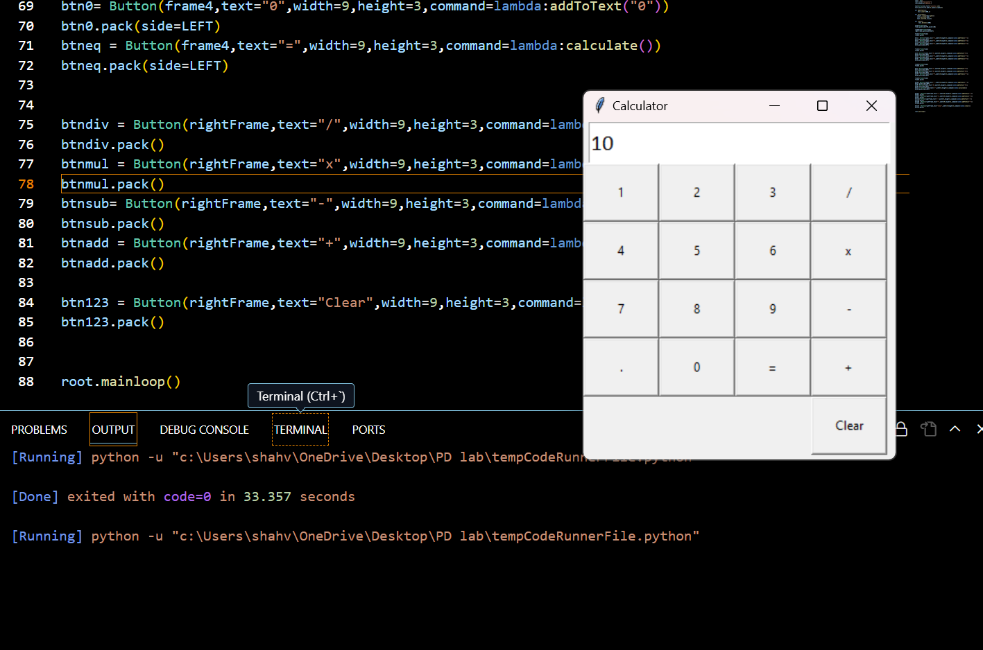

Conclusion:

Tkinter is a popular and widely used Python library for creating graphical user interfaces (GUIs). It provides a simple and easy-to-use interface for creating windows, buttons, labels, text boxes, and other GUI components. We get to learn about new and interesting topics. Tkinter is one of them.